
Mawlana Bhashani Science and Technology University
Sontosh, Tangail-1902
Department of Information and Communication Technology

Lab Report

Lab Report no : 06
Name of the report : Implementation of database triggers.
Course title : Database Management System Lab
Course code : ICT-2110

Submitted By | Submitted To
Name: Monirojjaman Ayoive  ID: IT-23013  2nd Year, 1st Semester  Session: 2022-2023  Dept. of ICT, MBSTU | Dr. Md. Abir Hossain  Associate Professor  DEPARTMENT OF INFORMATION AND COMMUNICATION TECHNOLOGY  MAWLANA BHASHANI SCIENCE AND TECHNOLOGY UNIVERSITY
Date of Performance: 11-01-2025 Date of Submission: 18-01-2025
Experiment No: 06
Objective:
The objective of this lab is to understand the concept and implementation of database triggers, specifically BEFORE INSERT, AFTER INSERT, BEFORE UPDATE, AFTER UPDATE, BEFORE DELETE, and AFTER DELETE triggers.
Theory:
A trigger is a database object that is automatically executed when a specified event occurs in a table. Triggers can be used to enforce business rules, validate data, maintain audit logs, and perform other automated tasks.
Types of triggers based on execution time:
- BEFORE Trigger: Executes before the specified operation (INSERT, UPDATE, DELETE).
- AFTER Trigger: Executes after the specified operation.
Triggers are created using the CREATE TRIGGER statement in SQL.
Required Instruments:
- MySQL 9.1.0 Command line Client.
- Computer (at least 4GB RAM).
Implementation: Below are the implementations of different types of triggers in SQL.

Before Insert Trigger:
In this implementation, we create two tables: Customer and Account. The Customer table stores customer details, while the Account table holds financial information.
SQL expression of Customer table: 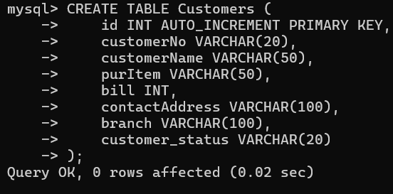

SQL expression of Account table:
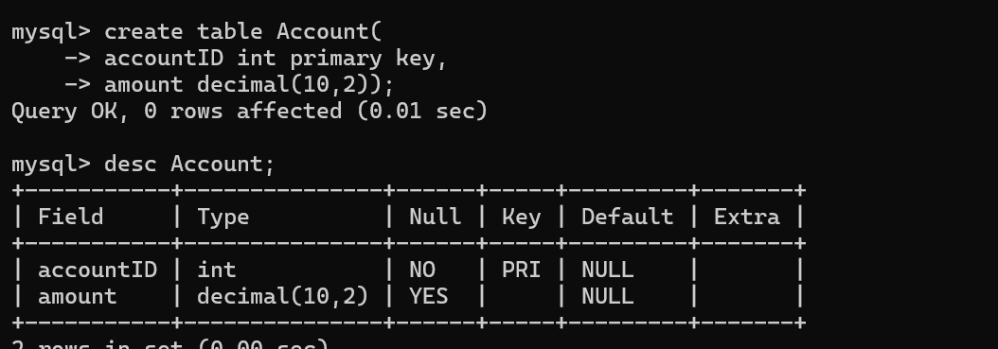

SQL expression of before insertion trigger:
This trigger automatically assigns a customer_status based on the bill amount before inserting the record.
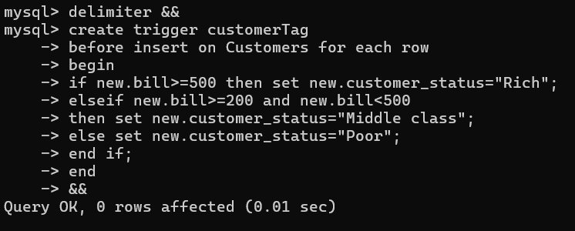

Inserting Data and Testing the Trigger :
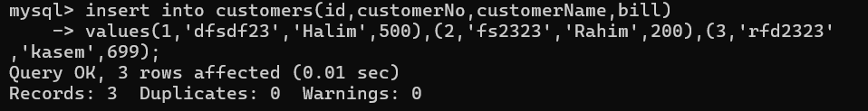
Expected Result: The customer_status should be automatically set based on the bill amount.
Result & Output: After executing the above insert statements, the Customer table will have the following data:
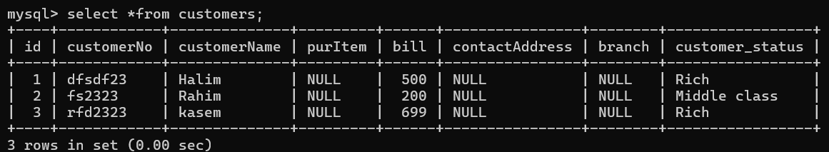

After Insert Trigger on Employees Table
In this implementation, we create two tables: employees and employees_audit. The employees table stores cemployee’s details, w hile the employees_audit table holds id and action information.
SQL expression of employees table:
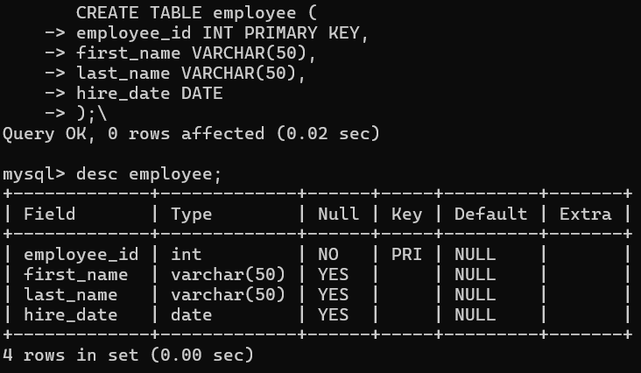

SQL expression of employee_audit table:
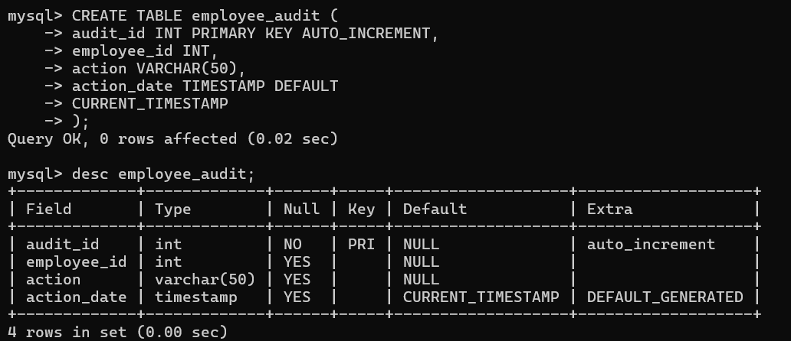
SQL expression of after insertion trigger : 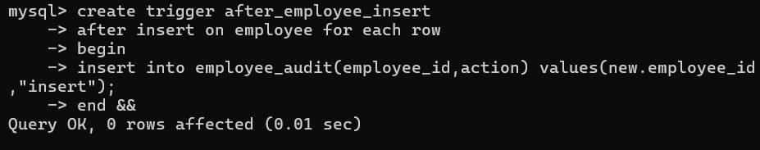
Inserting Data and Testing the Trigger :
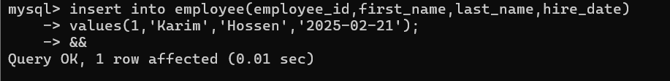
Expected Result: A new row should be inserted into the employee_audit table recording the insertion action .
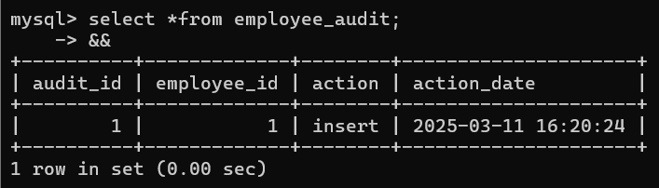

Before Update Trigger:
Prevent negative price values. Log old and new prices when a price change occurs.
SQL expression of products table : 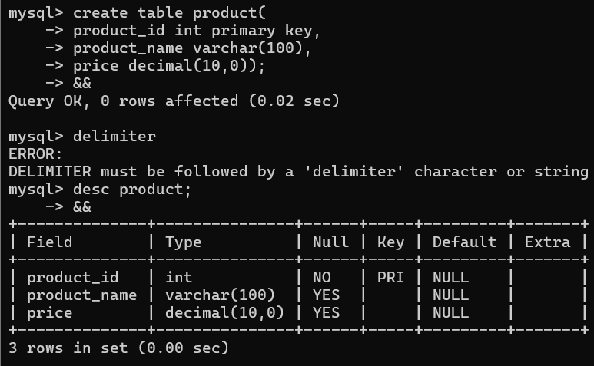
SQL expression of price_change_log table : 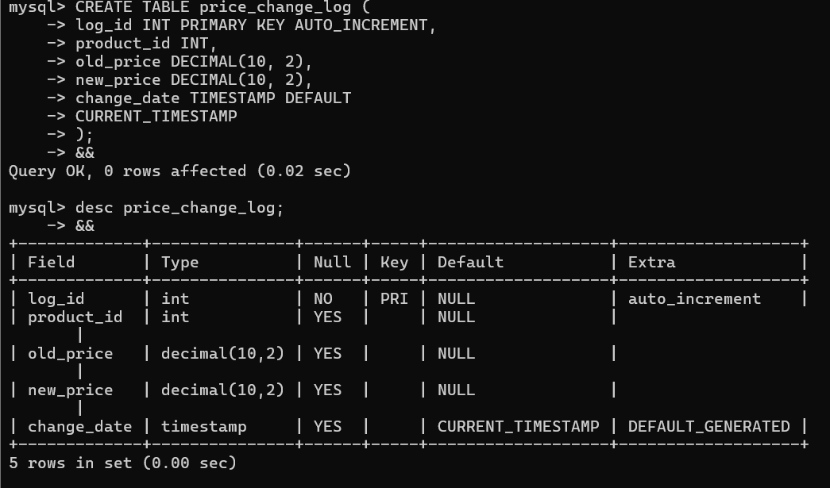
SQL expression of before update trigger:
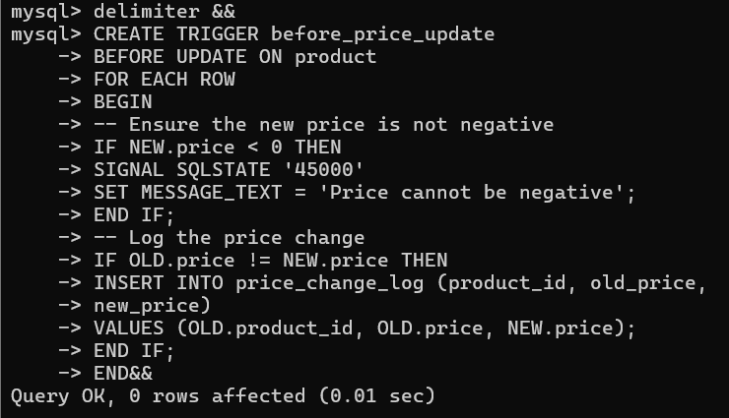

Insert Sample Data
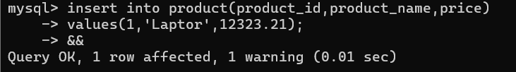
Update the Product Price (Trigger Execution)
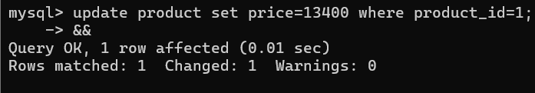
Verify the Price Change Log : SELECT * FROM price_change_log;
Expected Output
- If a valid price update occurs, an entry is added to price_change_log.
- If an attempt is made to set a negative price, an error message (Price cannot be negative) is displayed.
Example output from price_change_log after a successful price update:
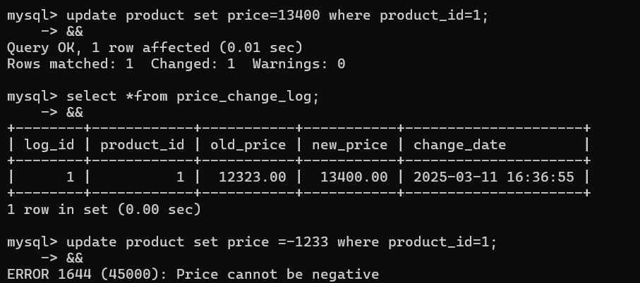
After Update Trigger:
SQL expression of employee table:

SQL expression of employee table:

SQL expression of employee table:
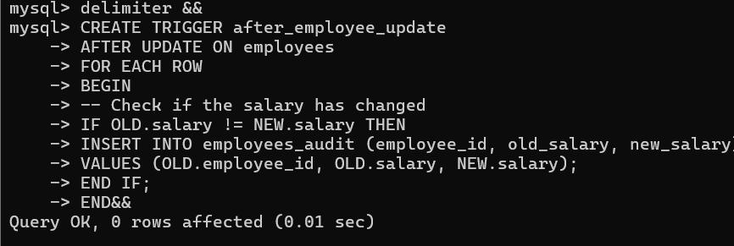

Inserting an Employee Record and Updating Salary :
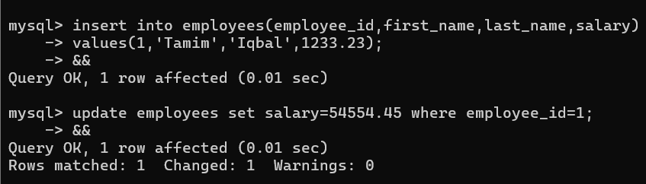
This update should trigger an audit log entry.
Verifying the Audit Log : SELECT * FROM employees_audit;
This query displays recorded salary changes.
Results :
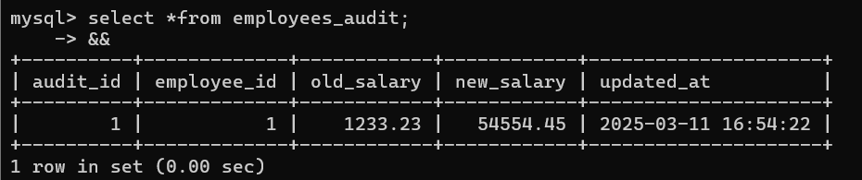
The table confirms that salary changes are logged correctly.

BEFORE DELETE Trigger in MySQL
SQL Expression for employee1 table :

This table stores employee details, including department information.
SQL Expression for deleted_employees_log table :

The deleted_employees_log table records deleted employees along with a timestamp.
SQL Expression before delete trigger table :

This trigger executes before an employee is deleted, storing the deleted employee's ID in deleted_employees_log.
Inserting Employee Records

Deleting an Employee Record :
Verifying the Log : SELECT * FROM deleted_employees_log;
This query retrieves deleted employee records.
Results:

The table confirms that employee ID 3 was logged before deletion.

AFTER DELETE Trigger in MySQL
SQL Expression for employee2 table :

This table stores employee details, including department information.
SQL Expression for employee1_audit table :
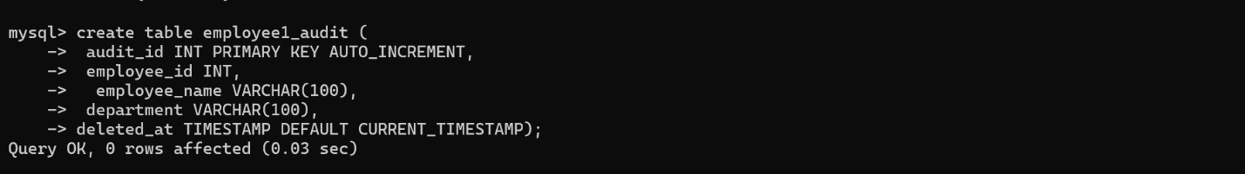
This table stores employee details, including department information.
SQL Expression of after delete trigger :
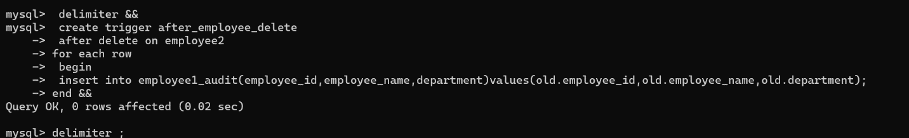
This trigger executes after an employee is deleted, storing the deleted employee's details in employee1_audit
Inserting Employee Records:
Deleting an Employee Record :
This deletion should trigger an entry in employee1_audit.
Verifying the Log : SELECT * FROM employee1_audit;
This query retrieves deleted employee records.
Results:
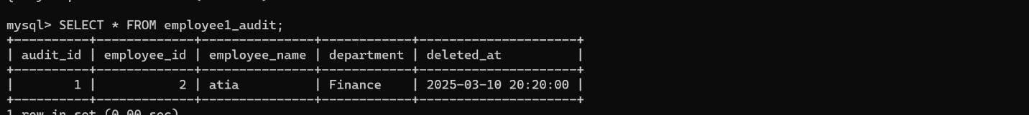

Conclusion:
This lab helped in understanding how triggers work and how they can be used to enforce business rules and maintain logs in SQL databases.

